International Symposium on Transportation Recorders
May 3 - 5, 1999 Arlington, Virginia

Reducing Highway Deaths and Disabilities with Automatic Wireless Transmission of Serious Injury Probability Ratings from Crash Recorders to Emergency Medical Services Providers
Howard R. Champion, Research Professor of Surgery, University of Maryland, Principal Investigator,
JS Augenstein, Professor of Surgery, University of Miami; B Cushing, Surgeon, Maine Medical Center; KH Digges, Professor of Engineering, George Washington University; R Hunt, Emergency Physician, State University of NY, Syracuse; R Larkin, Emergency Physician, American College of Emergency Physicians; AC Malliaris, Mathematician, George Washington University; WJ Sacco, Mathematician, ThinkSharp, Inc.; JH Siegel, Professor of Surgery, University of Medicine and Dentistry of New Jersey.
KEYWORDS Highway, Crash, Treatment, Urgency
INTRODUCTION
In 1997, the National Transportation Safety Board (NTSB) made three particular recommendations that are helping to build an "Automatic Lifesaving System for a Safer America". The NTSB is to be commended for its recommendations on crash recorders (H-97-18 and H-97-21), for holding this Symposium, and for its recommendation (H-96-13) to increase funding for motor vehicle safety efforts at the State level.
To the National Highway Traffic Safety Administration (NHTSA):
- H-97-18 "Develop and implement, in conjunction with the domestic and international automobile manufacturers, a plan to gather better information on crash pulses and other crash parameters in actual crashes, utilizing current or augmented crash sensing and recording devices." [1]
To the Domestic and International Automobile Manufacturers:
- H-97-21 "Develop and implement, in conjunction with the National Highway Traffic Safety Administration, a plan to gather better information on crash pulses and other crash parameters in actual crashes, utilizing current or augmented crash sensing and recording devices." [2]
To the Governors and Legislative Leaders of the 50 States and U.S. Territories, and to the mayor and Chairman of the Council of the District of Columbia:
- H-96-13 "Emphasize the importance of transporting children in the back seat of passenger vehicles through educational materials disseminated by the State. Consider setting aside one-tenth of 1 percent from all motor vehicle insurance premiums for policieswritten to establish a highway safety fund to be used for this and other safety efforts. (Urgent)" [3]
The first two are on the NTSB's list of "Most Wanted Transportation Safety Improvements." The third recommendation, when fully implemented will generate about $100 million per year for State highway safety efforts. These funds can be used to organize a nationally compatible Automatic Lifesaving System in each State.
This paper addresses the building of a national Automatic Life-Saving System based on these pioneering NTSB recommendations to realize the full potential of new technologies as soon as possible. The work described herein is the result of efforts of a multidisciplinary team of trauma surgeons, emergency physicians, crashworthiness engineers and statisticians. The team examined the safety potential of communicating crash recorder data via wireless telecommunications with Automatic Crash Notification (ACN) technology to improve emergency transport and treatment of crash victims.
The research team developed URGENCY software for automatic and instant conversion of crash recorder data into a crash severity rating that calculates the probability of the presence of serious injuries in any given crash. URGENCY software version 1.0, now in the public domain, can improve triage, transport, and treatment decision-making for highway crash victims.
FINDINGS: The Problem
By the year 2005, the U.S. Department of Transportation projects that the annual number of crash deaths will rise to 51,000 people killed per year - despite its current safety programs [4]. Historically in motor vehicle crashes, more than 3 million Americans have been killed, and 300 million injured. That is more than 3 times the number of Americans killed, and 200 times the number wounded in all wars since 1776.
Currently about 42,000 Americans die from crash injuries each year. Nearly 20,000 people die each year before receiving hospital care. Many of the remaining 22,000 people die after reaching hospital too late to be saved. That represents the mortality part of the problem. The morbidity part of the problem involves an estimated 250,000 Americans suffering seriously life-threatening injuries in crashes each year [5,6,7].
The economic costs of crash injuries incurred each year amount to an estimated $100 billion in current dollars. Including compensation values for intangibles such as pain & suffering, the comprehensive costs of crash injuries incurred each year amount to about $350 billion [7]. The human costs to individuals and families of the deaths, injuries, and disabilities incurred in crashes, each year, are unmeasured tragic losses.
Each year, on the 4 million miles of roads in the U.S., 5 million Americans are injured in 17 million crashes involving 27 million vehicles. Among those 27 million crash-involved vehicles, approximately 250,000 Americans suffer seriously life-threatening injuries -- at unpredictable times and places [7]. Thus, the focus of this research was "How to identify, rapidly and automatically, those vehicles in which the 250,000 people are seriously injured and need time-critical emergency care?"
Currently, of the 42,000 crash deaths each year, nearly 20,000 victims die at the scene. At the scene, about 13,500 people die from injuries in rural crashes and about 6,500 in urban crashes. Of the 22,000 crash deaths that are taken to hospital, many die because they arrive too late to be saved. Thousands of crash deaths occur each year in which the victim did not arrive at a hospital - much less at a trauma center -- within the "Golden Hour."
The Safety Improvement Solution: Time, Technology, and Urgency Information
Time Available to Prevent Deaths and Disabilities:
Emergency medical care experience has shown that for many serious injuries, time is critical. As described by RD Stewart:
"Trauma is a time-dependent disease. `The Golden Hour' of trauma care is a concept that emphasizes this time dependency. That is in polytrauma (typically serious crash victims suffer multiple injuries) patients, the first hour of care is crucial, and the patient must come under restorative care during that first hour.... Pre-hospital immediate care seeks to apply supportive measures, and it must do so quickly, within what has been called the `Golden Ten Minutes.'" [8]
The goal in trauma care is to get seriously injured patients to a trauma center for diagnosis, critical care and surgical treatment within the "Golden Hour" [8, 9,10,11]. To get the seriously injured patient into the operating room of a trauma center with an experienced team of appropriately specialized trauma surgeons within the "Golden Hour" requires a highly efficient and effective trauma care system.
The time/life race of the "Golden Hour" to deliver patients to definitive care consists of the following elements:
(1) Time between crash occurrence and EMS Notification,
(2) Travel time to the crash scene by EMS,
(3) On-scene EMS rescue time,
(4) Transport time to a hospital or trauma center,
(5) Emergency Department resuscitation time.
Now, increasingly, there are new opportunities in each category to act more rapidly and effectively to transport patients to definitive care within the "Golden Hour."
The need and the opportunities are especially important on rural roads where more than 24,000 fatalities occur in crashes each year. Data collected by the National Highway Traffic Safety Administration (NHTSA) show that only 24 percent of crashes occur on rural roads, but nearly 59 percent of the crash deaths occur on rural roads. "Delay in delivering emergency medical services is one of the factors contributing to the disproportionately high fatality rate for rural crash victims." according to NHTSA [12].
In urban areas there are about 17,000 fatalities each year. In both urban and rural areas, a substantial number of fatal crashes occur at night or early morning. About 16,000 (43%) fatal crashes occur each year between the hours of 9:00pm and 9:00am, times when crash discovery, notification and emergency response are more likely to be slower. Table 1 lists the average time intervals experienced in fatal crashes in the U.S. in 1997 [13]. Entry number 5 for the Emergency Department Resuscitation time interval is not based on data, but is an assumed value of 15 minutes for the purpose of relating pre-hospital times to the "Golden Hour" for the delivery of definitive care to save seriously injured patients.
Table 1. Average Elapsed Times in Fatal Crashes in 1997 (Minutes)
Time Intervals | Urban | % Unknown | Rural | % Unknown
1. Crash to EMS Notification | 4 | 48 | 7 | 35
2. EMS Notification to Scene | 6 | 49 | 11 | 34
3. Scene Arrival to Hospital | 26 | 72 | 36 | 67
4. Crash to Hospital Arrival | 35 | 72 | 52 | 68
5. ED Resuscitation (No Data) | 15 | 100 | 15 | 100
Totals | 50 |  | 67
Note: Average times consist of shorter and longer times and vary greatly by State.
1. Elapsed Time from Crash to EMS Notification:
More than 10 minutes elapse before EMS is even notified (much less able to deliver pre-hospital emergency care within the Golden Ten Minutes) in thousands of fatal crashes each year. In 1997, there were 21,809 fatal crashes with both times recorded, or 59% of the total 37,280 fatal crashes. Among the crashes with recorded times, EMS Notification exceeded 10 minutes in 2,707 (19.4%) of the rural fatal crashes, and in 497 (6.3%) of the urban fatal crashes. Reported fatal crashes with long elapsed notification times amounted to 3,204. Among the 15,471 fatal crashes with unreported times, there probably were many more long elapsed EMS Notification times that would raise the total.
Since 1992, there has been a steady reduction in the national average of both rural and urban fatal crash notification times -- down about 30%. This improvement has been coincident with, and apparently significantly caused by, the increasing use of wireless telephones by "Good Samaritans." (Note, however, that comparable improvements have not been observed in the subsequent critical time intervals discussed below.[5])
In the future, ACN will reduce many of the longer times dramatically. With ACN, all crash notification times, not just average notification times, will be reduced to about one minute.
Reductions in rural average crash notification times from 9 minutes to 1 minute after the crash have been estimated to potentially save 3,000 lives per year [14].
2. Elapsed Time from EMS Notification to EMS Arrival at the Scene:
In the future, ACN, URGENCY, crash location information, and navigation equipment on board rescue vehicles increasingly will be able to shorten this time interval.
3. Elapsed Time from EMS Arrival at Scene to EMS Arrival at Hospital:
In the future, ACN + URGENCY technology will help dispatchers, instantly and automatically, decide to send extrication equipment in severe crashes, thereby, saving additional precious minutes in this time interval.
4. Elapsed Pre-hospital Times - Time of Crash to Hospital Arrival:
Nationwide, data (where both times are reported) show that in about 2,300 fatal crashes each year, this time from crash to hospital (not necessarily Trauma Center) arrival, exceeds 60 minutes. The actual number is much greater considering the large number of crashes where times were unknown.
In the future, ACN + URGENCY information and navigation technologies will make it possible to greatly increase the number of people in potentially fatal crashes who get to hospital well within 60 minutes.
5. Emergency Department Resuscitation Times:
Current medical references allocate 15 minutes to Emergency Department (ED) resuscitation times for tests, diagnoses, decision making on treatment strategies, and required pre-operating room procedures before surgical care [11]. Table 1 adds the needed 15 minutes for ED resuscitation to the average reported times [13]. The result is that on rural roads with the average of 52 minutes that it takes to get a seriously injured patient to a hospital (often not a trauma center) in the average fatal crash, the "Golden Hour" is lost. Thus, the "Golden Hour" is exceeded in many thousands of fatal crashes each year. And currently, too many time/life races are lost.
In the future, URGENCY information on injury probabilities that are transmitted ahead to the hospital at the time of crash probably will include pre-existing medical conditions, blood types, reactions to medications, etc., that will help reduce time currently lost in this time interval.
Lost "Golden Hours" and Lost Lives - During 1996 and 1997, for example, the reported average elapsed time from crash to arrival at a hospital (without time measured for ED resuscitation) in rural fatal crashes exceeded 60 minutes in eight States. The States in alphabetical order were: Arizona, Louisiana, Michigan, Montana, Nevada, North Dakota, Texas, and Wyoming [13].
In 1997, there were 37,280 fatal crashes in the U.S. Data from `time of crash' to `time of hospital arrival' is available for 11,075 (or only 30%) of these fatal crashes. Among the 11,075 fatal crashes with both times reported, there were 2,336 fatal crashes where the elapsed time to hospital arrival was reported to have exceeded 60 minutes. Thus, 21% of all fatal crashes with both times recorded exceeded 60 minutes [13]. If times were reported in all cases, not just cases with recorded times, the number of all fatal crashes exceeding 60 minutes would be much higher.
Table 2 provides data on the number of fatal crashes reported with time of hospital arrival exceeding the "Golden Hour" increasing over the period 1993 through 1997.
Table 2. Fatal Crashes
Reported Elapsed Times from Crash to Hospital Arrival
Between 61 - 120 Minutes (Number & Percent Reported)
Elapsed  Times | 1993  Urban | 1993  Rural | 1994  Urban | 1994  Rural | 1995  Urban | 1995  Rural | 1996  Urban | 1996  Rural | 1997  Urban | 1997  Rural
>60min | 301 | 1,817 | 346 | 1,934 | 314 | 1,897 | 323 | 1,995 | 319 | 2,017
Reported | 7.4% | 29.2% | 7.7% | 30.9% | 7.5% | 30.8% | 7.4% | 30% | 7.5% | 29.6%
New Technologies:
As described in AirMed [15], the technologies are now increasingly available to make dramatic improvements in public safety through faster and smarter emergency medical care:
- Wireless telecommunications technologies now enable people to make calls for emergency help without having to search for a land-line telephone, thereby, saving precious minutes from crash notification times.
- Wireless location technologies and Global Positioning System (GPS) technologies can enable calls to be instantly located by emergency responders - thereby taking the "search" time out of "search and rescue".
- Air bag crash sensor technologies on board vehicles now enable objective and instant measures of the severity of crashes. These crash severity sensor measurements can be automatically communicated to EMS providers, via cellular telephone, as a simple numerical probability of the presence of a serious injury. This will save the time currently lost while waiting for the first responder to travel to the scene for visual evaluation of the seriousness of the crash before dispatch of appropriate EMS care such as helicopter rescue.
Automatic Crash Notification (ACN) technologies using crash sensors, GPS, and wireless telephones are now being installed on production cars. Automobile manufacturers including GM, Ford, BMW, and Nissan are offering first generation versions of ACN technology (that report when an air bag deploys) in 1999 model year vehicles in the U.S. The U.S. Department of Transportation (DOT) currently is installing a more advanced version of ACN technology in 1,000 vehicles in the Buffalo, New York area. This ACN system, built by Calspan, measures crash forces in all types of crashes (not just air bag deployment crashes) and automatically transmits URGENCY injury severity probabilities.
The DOT contract with the Calspan Corp. of Buffalo, N. Y., is testing this advanced ACN technology that provides for an automatic, crash-activated, call for help using an on-board cellular telephone to transmit voice and data. The call electronically communicates information on the location of the crash and the severity of the crash (for all major crash modes: frontal, side, rear impacts, and rollover). It also transmits data on vehicle pre-crash speed, direction of travel, and vehicle identification information including many attributes such as vehicle type. The equipment is being installed by the Cellular One Company in a fleet of 1,000 vehicles in the Buffalo area. The Erie County Medical Center is participating in the evaluation of this system. URGENCY software is in use with the Calspan system currently, and in the future can be used on all motor vehicles.
Urgency Information:
In March of 1997, for the first time, the research team developed URGENCY version 1.0 computer software to improve computer-assisted dispatch of rescue resources using crash recorder data. The goal was to develop a system that instantly, and automatically, identifies the approximately 250,000 crash vehicles with serious injuries from among the 27 million vehicles in crashes each year.
The URGENCY triage algorithm was developed by the team to predict injury severity probabilities based on vehicle, occupant, and crash parameters. All parameters, for which data was available, were evaluated in terms of their power to predict the probability of serious injury.
Through an extensive series of logistic regression analyses of national crash data files, the team related crash forces (measurable in crash severity recorders) to serious injury probabilities. Probabilities were developed for all major crash modes: frontal, side impacts, rear impacts, and rollovers - both individually and in combination to cover complex crashes. Injury probabilities were calculated for vehicle and crash severity parameters of Crash Force (Crash Delta Velocity), Principal Direction of Crash Force, Rollover (number of quarter turns), Vehicle Weight, and Safety Belt Use.
Injury probabilities were also developed for the powerfully predictive occupant and crash parameters of Age, Gender, Entrapment, and Ejection -- data that may be obtained by EMS dispatchers via hands-off, two-way cellular communications with the vehicle occupants and bystanders. The Age parameter, for example, predicts that the probability of a serious injury for a 50-year-old in a crash of a given Delta V is nearly double the probability of serious injury for a 25-year-old [16].
With URGENCY software, upon vehicle impact, crash sensor measurements are instantly, and automatically, translated into a single figure rating of urgency from 0 to 100% probability of a serious injury being present in the crash.
Figures 1 and 2 show an URGENCY bar chart that a dispatcher would see on the computer screen and a map location of the crash site. For example, Figure 1 shows an URGENCY reading of 89% probability of the presence of at least one serious injury of AIS 3, or greater, severity. In this example, this 89% URGENCY rating would be triggered in a side impact crash of 38 mph Delta V, involving a rollover with a female occupant (age and gender can be programmed into the vehicle algorithm as the principal driver).
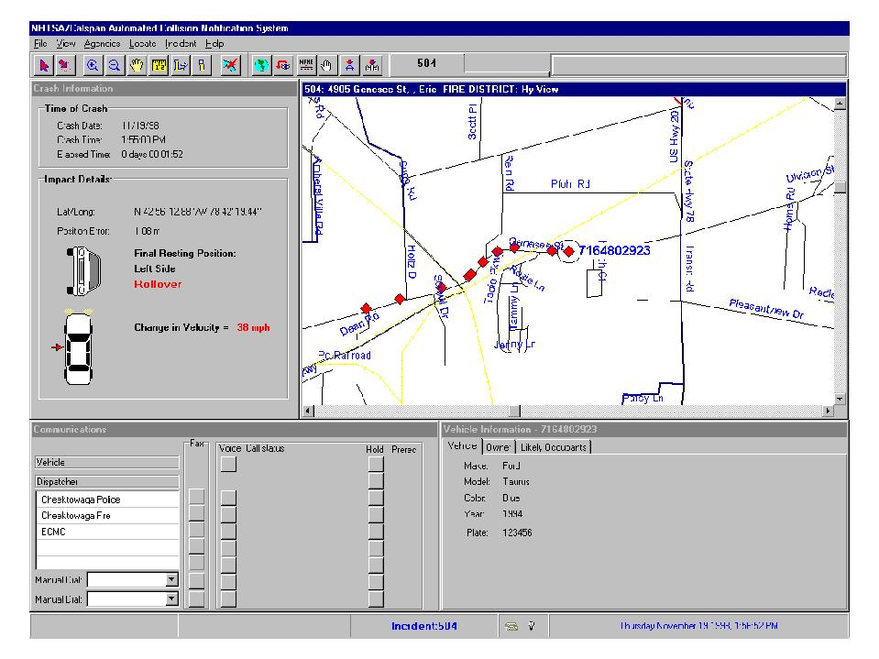
Figure 1.
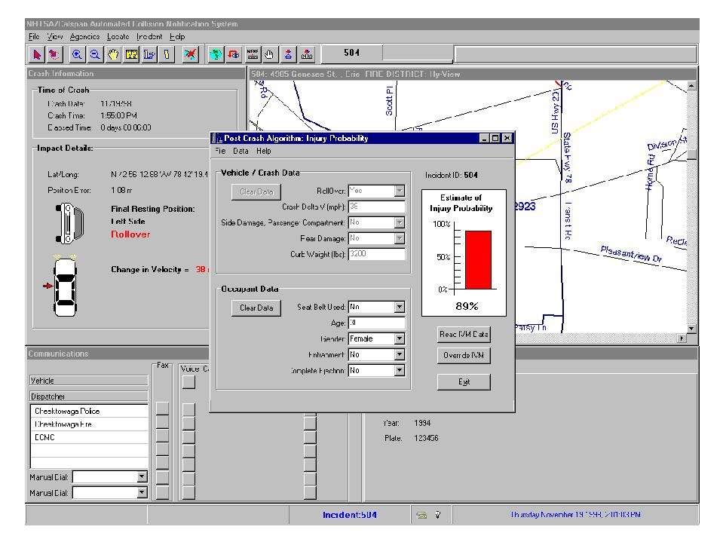
Figure 2.
Future versions of URGENCY will include other sensor data such as pre-crash speed and braking deceleration, crash pulse, air bag time and level of deployment, seat belt forces, door openings, presence or absence of fire, and number, size and seating positions of occupants. In addition, medical records can be used in upgraded URGENCY computations. Medical records also can be instantly sent electronically to the Emergency Department containing data on blood type, drug reactions, current medication, etc., so that this information arrives before the patient arrives, and further expedites and improves emergency treatment decision-making. [A free copy of URGENCY Software 1.0 is available on request from HRChampion@aol.com]
To gain the benefits of this exciting and far-reaching capability, continued research is needed to relate these new variables to injury probabilities. Further development of the URGENCY algorithm based on interdisciplinary research is vital. Investigation and documentation of crashes with recorders needs to be accelerated. The injuries to occupants need to be correlated with data from the recorders. The cooperation of trauma physicians, crash investigators, biomedical engineers, trauma care providers, and vehicle safety engineers is essential to the rapid and accurate development of this breakthrough safety technology.
Taken Where - Trauma Center, Nearest Hospital, or Morgue?
During the past ten years, nearly 400,000 Americans died from crash injuries. Nearly 50 percent were not taken to a hospital for treatment [5]. In too many cases, especially in rural areas, people die without having obtained definitive care at a trauma center within the "Golden Hour." Definitive care includes thorough, timely, and accurate diagnoses, intensive critical care, and trauma teams with surgeons specialized in brain injuries, internal organ injuries, and orthopedic injuries.
Currently, each year, 20,000 people die at the scene. The problem is greater in rural areas. Although in rural and urban areas the number of crash deaths of people taken to a hospital for treatment are about equal at 10,500 per year, the number not taken in rural areas (13,500) is about twice the number in urban areas (6,500). [Historical data by State are available upon request from HRC.]
Notification times and response times will improve with ACN and URGENCY technologies. Helicopter and other emergency response vehicles will be able to reach the scene faster using on-board navigation systems that will use the ACN crash location coordinates. Rescuers also increasingly will have on-board navigation guidance to the scene via the "fastest route." And with instant URGENCY information on the probability of serious crash injury, we will be able to do a better job saving lives and preventing disabilities by taking people to the right place the first time, rather than to the wrong place [17, 18].
URGENCY software will enable us to advance beyond current rescue practices - especially regarding helicopter dispatch. In general, under current practices, when a crash occurs - however serious it may be - someone in authority (police, fire or EMS) first, must travel over land to the scene, second make a determination that the seriousness requires a helicopter response, and third send a radio request for air medical assistance. And if, and when, the request is granted, only then does the process of helicopter deployment begin. In the future, computer assisted dispatch protocols will be developed that will expedite this process - with lifesaving results.
The Benefits
Several projections of benefits estimate that thousands of lives could be saved each year. The U.S. DOT cites a study projecting that benefits of an ACN system would result in a 12% reduction in rural crash deaths and save an estimated 3,000 lives each year when all rural crash notification times are reduced to 1 minute [14]. The Europeans project a 15% increase in survival rates from in-vehicle "automatic emergency call" systems [19]. The Japanese aim to cut in half their current emergency response times [19]. In addition to lives saved, it is reasonable to expect significant reductions in disabilities and human misery through the faster and more intelligent delivery of emergency medical care for non-fatal, but serious, injury crashes.
Perhaps the most significant benefits of ACN + URGENCY will result from the data generated on crashes, injuries, treatments and outcomes. This data will form the scientific basis for continuous improvements in vehicles, roadways, driver behavior and emergency care. Programs in crash injury prevention and treatment will have a new scientific resource for advances in the protection of the motoring public.
The Race To Produce Automatic Lifesaving Systems
Currently in the race to produce a national Automatic Lifesaving System, Japan is ahead of the U.S. and the rest of the world. Toyota, Nissan, and other auto manufacturers plan a national ACN program in Japan in cooperation with the National Police Agency, the Fire Defense Agency, and telecommunications companies. Daimler-Benz also announced plans to start a similar emergency call service in Japan on September 1, 1998. E Call Japan was set up jointly by Daimler-Benz, Nippon Telegraph and Telephone Corp., Tokio Marine and Fire Insurance Co. and others. The auto manufacturers expect that these ACN services will halve the current average emergency response time of 30 minutes in Japan [19].
In America, a group of physicians, nurses, law enforcement groups, and others have joined with wireless communications companies to create the ComCARE (Communications for Coordinated Assistance and Response to Emergencies) Alliance. The ComCARE Alliance supports legislation to accelerate ACN development and deployment.
Now that basic research has been done, there remains an urgent need for a national program in America, under medical direction, to involve the nation's emergency medical infrastructure. Leadership, time, people, and money are needed to deliver the lifesaving benefits that are now possible with deployment of these technologies. Systems will have to be improved at all trauma centers/systems to apply this technology. This will involve systems integration of hardware and software, development of new protocols, and training to deliver the benefits of improved triage, transport and treatment to people in need of urgent care.
To create an Automatic Lifesaving System nationwide we need to expand the research, development, testing and evaluation (RDT&E) program of the 1,000 cars in Erie County, N. Y. One problem is that this fleet is too small to experience enough serious injury crashes. Statistically we can expect less than one serious injury crash during the one-year test. This operational test needs to be expanded to increase both the number of vehicles and the length of the test period -- and to be conducted at a larger number of trauma centers geographically located across the nation - at least one in each of the 50 States. The Automatic Lifesaving System must be nationally compatible so that a motorist from one State can be similarly protected as the car travels across State lines.
Congress has already funded DOT research on crashes at trauma centers in 9 States (AL, CA, DC, FL, MD, MI, NJ, NY, and WA). This research needs to be expanded to each of the remaining States.
Congress authorized $2 million, per year, for the next 6 years to perform research at a new Calspan research center at the State University of NY at Buffalo. RDT&E programs in each of the 50 States are needed for trauma care systems to upgrade the necessary emergency medical infrastructure in each state to deliver the full lifesaving potential of these technologies to the American people. A proposal of $100 million per year in research may seem costly, but in fact, it is far more costly to not conduct such a program. The savings become clear when the proposal is compared with the more than $150 million in new economic costs ($600 million in comprehensive costs) incurred by the 115 crash deaths and 500 serious injuries that occur on U. S. roads - every day. This research will lead to the saving of many lives each day. In fact, one-percent improvement, i.e., saving just one life each day, will save the nation far more than the cost of the program.
The U.S. Department of Transportation (DOT) is currently spending less than 0.01 percent of the $38 billion per year DOT budget on Automatic Crash Notification. Yet motor vehicle crashes account for more than 90 percent of the nation's transportation safety problem.
Building A Safer America
To build a safer America, we must create a system by which the emergency medical community continuously improves its ability to deliver care. ACN technology provides an opportunity and a mechanism for the continuous improvement of emergency medical care. ACN can generate the data for quality improvement programs at all levels of prevention and treatment.
With a medically directed national program of research, development, testing and evaluation we can improve the nation's emergency medical infrastructure to use these technologies to deliver definitive care. As we do so, we will create a research mechanism for continuous improvement of emergency medical care in its broadest sense. The benefits of ACN technology to the public will be much broader and greater than just improving care for crash victims. For example, when cars are so equipped, citizens (for themselves or as Good Samaritans) will be able to make emergency calls for such incidents as heart attacks, strokes, injuries due to falls and other causes-even crimes.
The ability to make instantaneous wireless calls for emergency help (with automatic location) has been strongly identified in market research, both by the auto industry and the cellular industry, as products and services the public is willing to pay for as consumers. One market research study found that 48% of car buyers said that Automatic Dial 911 Safety equipment is "important" or "very important" in their purchase decisions [20]. More recently, a Louis Harris poll for Advocates for Auto and Highway Safety found 68% would like to have such safety equipment in their car [21].
GM recently offered its ($1,300 MSRP) OnStar equipment free with "installation at no extra charge on every new Buick" model under the advertisement headline: "You can't put a price tag on security. So we didn't." However, GM does require a one-year pre-paid OnStar subscription and cellular service. [22]. And GM's OnStar currently only provides crash notification to a private OnStar call center, that then calls for public "911" rescue service. And OnStar currently is limited to only those crashes in which an air bag deploys (primarily frontal crashes, not rollovers, side, and rear impacts).
The cost of the more advanced ACN safety equipment provided by Calspan that covers all crash modes, according to Calspan and the government is estimated "at between $200 and $300" [23]. Moreover, the cost of electronics equipment is dropping fast as the technologies and competition develop and production volume increases.
The public clearly wants, and the technology is now available for, an intelligent transportation system that delivers help wherever and whenever Americans are in danger-in time to save lives.
Conclusions and Recommendations
The research team concluded that significant improvements in emergency care could be achieved by using new technologies. The lifesaving and disability-reducing benefits of faster, and more informed, emergency responses are expected to be substantial. Instant, and automatic, communications of information on crash occurrence, location, and injury probability via wireless communications to EMS could save thousands of lives each year [14, 19]. To realize the lifesaving and disability reducing benefits of this technology requires a nationally coordinated program to develop a nationally compatible system of major trauma care for crash victims. Nationally coordinated multidisciplinary research, development, testing, and evaluation on a state-by-state basis is needed.
The recommendations of the NTSB already are moving the nation to a safer highway environment. Further attention by the NTSB is needed to develop and deploy the nation's Automatic Lifesaving System as soon as possible to reduce the losses in lives and livelihoods of thousands each year. As the NTSB considers both the immediate and intermediate-term uses of crash recorder data for the continuous improvement of safety on U.S. roads, its recommendations will move the nation closer to becoming a safer America.
Hopefully the NTSB will consider issuing additional recommendations to governmental agencies at the federal and State levels, as well as to private sector organizations to build the Automatic Lifesaving System.
- Federal and State agencies, i.e. GSA and State Police Departments, could purchase Calspan-type crash recorders for their vehicles to begin the R. D. T. & E. process of saving lives and encouraging deployment of this technology as was done with air bag technology in the 1980's. In the 1980's air bag demonstration fleets purchased by GSA and insurance companies saved the lives of employees and provided market incentives for air bag technology development. Today, Calspan-type ACN crash recorders can be installed on new vehicles (or retrofitted on existing fleets) for less than $300 per car. A fleet of 50,000 cars could cost about $15 million. Such a fleet size is needed to achieve statistically significant results. Such a national operational test program could be conducted with University-based Trauma Centers doing crash injury investigation work in each of the 50 States. This could be part of an expanded NHTSA Crash Injury Research and Engineering Network (CIREN) currently in operation at 7 Trauma Centers. The results of crash investigations in each State will provide valuable information to the various agencies of State and local governments on how to improve both the technology and the safety systems in their State.
Indeed, the NTSB could be connected to the existing CIREN centers, and ultimately to an expanded 50-State CIREN, so that it can electronically obtain all cases as they are entered into the CIREN system. This would give NTSB an expanded real-time data collection tool in serious injury highway crashes. Thus, the NTSB could economically become more scientifically involved in medical and engineering investigations of a larger number of serious injury motor vehicle crashes each year. Such an increase would result in a level of NTSB involvement more commensurate with the magnitude of the safety problems posed to the nation by motor vehicle crashes than is possible with current NTSB resources.
- Governors need to direct the resources of their State highway and police departments, State University Medical Centers, Trauma Centers, EMS, and highway safety offices to develop the wireless safety communications and the emergency transport and treatment infrastructures into statewide systems that are nationally compatible. The Federal government has an important role to fulfill in improving emergency transportation in all modes, especially helicopter rescue, when so many avoidable tragedies are time-critical. This role includes coordinating nationally compatible emergency communications standards and crash recorder data standards.
- Until such time that all vehicles are equipped with ACN + URGENCY systems integrated into a national Automatic Lifesaving System, we need to do a better job of locating crashes as soon as possible using existing wireless location technology. The FCC has ruled that wireless 911 calls shall have location information imbedded in the calls by the year 2001. Unfortunately, and fatally for many Americans, that rule is not being implemented on schedule. The wireless industry currently transmits nearly 100,000 emergency 911 calls each day - without location information imbedded in the call [24]. This is creating a major problem for emergency responders who don't know where the caller is located. Leadership is needed to move the nation to rapidly apply existing wireless location technologies. We must do better building the wireless infrastructure for the existing 70 million wireless phone users. They often could be helped with embedded location signals when they are endangered on our roads. They also could be more effective in their efforts as "Good Samaritans" to save their fellow Americans.
- Crash recorder data could be used in a national program for continuous improvements in the prevention and treatment of crash injuries. The systematic capture and organization of crash recorder data will enable citizens, governments (at all levels) and the auto, insurance, and health care industries to contribute to the building of a safer America on a solid scientific foundation of objective data. The technological availability of crash recorder data now provides the nation with the opportunity to improve upon the triage guidelines currently in use worldwide based upon work done a decade ago [25]. For one example of additional benefits with systematized crash recorder data, state highway departments could obtain a wealth of information, including location, on all serious injury crashes for continuous system improvements.
- As recommended recently by the National Academy of Sciences, in its Report Reducing the Burden of Injury, the need is clear for a federal re-commitment to Trauma Center/System Development in each of the 50 States to save people suffering from serious, time-critical, injuries. Whether the time-critical injuries are the result of crashes or other causes, the timely delivery of emergency care will help save lives and livelihoods. In addition, an advanced trauma care system will also result in saving the lives of people suffering from time-critical illnesses such as strokes and heart attacks and needing rapid and safe emergency medical transport and care [26].
Time is of the essence. But, it's not just a matter of time before we all have the safety benefits of these new technologies. It's also a matter of societal urgency that will determine how many avoidable tragedies the nation must experience before the Automatic Lifesaving System is saving lives. Building a safer America is a matter of time, money, public policy, political leadership and most importantly - peoples lives - both those lost and those saved.
Note: Table 3 provides a ranking of the States by 1997 crash fatality rates per 100,000 population.
Acknowledgments
This research was funded by the National Highway Traffic Safety Administration. The authors wish to thank Louis V. Lombardo for his assistance in this research. For more information, contact HRChampion@aol.com.
References
1. National Transportation Safety Board, Proceedings of the National Transportation Safety Board Public Forum on Air Bags and Child Passenger Safety, NTSB/RP-97/01, PB97-917001, October 1997, p. 17.
2. id., p. 18.
3. id., p. 27.
4. Testimony of Mortimer L. Downey, Deputy Secretary, U.S. Department of Transportation, before the U.S. Senate Committee on Environment and Public Works, Subcommittee on Transportation and Infrastructure, Feb. 13, 1997, p. 11.
5. NHTSA, Fatality Analysis Reporting System (FARS), Automated Data Files.
6. NHTSA, National Accident Sampling System (NASS), Automated Data Files.
7. NHTSA, The Economic Cost of Motor Vehicle Crashes, 1994, DOT HS 808 425, July 1996, pp. 1, 7, 8, 9, 59.
8. Stewart, RD, "Pre-hospital Care of Trauma," Chapter 3, p. 24, in McMurtry, R.Y. and McLellan, BA, Management of Blunt Trauma, Baltimore: Williams and Wilkins: 23-29; 1990.
9. JD Mayer, "Response Time and its Significance in Medical Emergencies," The Geographical Review, p.79. As noted by JD Mayer:
"The Emergency medical Systems Service Act (EMSS Act) of 1973 was passed by Congress to promote systematic planning and evaluation of regional emergency systems. The Act represented an attempt to coordinate a number of components in pre-hospital emergency cases, such as transportation, personnel, and facilities. One of the provisions of the EMSS Act is that 95 percent of all ambulance response times must be within twenty minutes in rural areas and within ten minutes in urban areas." (In 1996, only the state of Mississippi had average response times of greater than ten minutes in urban fatal crashes.)
10. M Smith, "Mechanism of Injury," Paramedic Field Care: A Complaint-Based Approach, American College of Emergency Physicians, 1997, edited by PT Pons and D Cason, Mosby-Year Book, St. Louis, MO. As taught in the text book Paramedic Field Care: A Complaint-Based Approach:
"Once a traumatic event has occurred, the survival clock begins ticking. The longer it takes to deliver a seriously injured patient to definitive care at the hospital, the less likely the patient's survival becomes. The time that passes during on-scene care is irreplaceable; whenever possible, it should be limited to 10 minutes or less."
11. NE McSwain, Jr., "Pre-hospital Care, Chapter 8," Trauma, 3rd Edition, DV Feliciano, EE Moore, KL Mattox, Appleton & Lange, 1996, pp. 109-110. As summarized in the reference work Trauma:
"The standard that field time should be no longer than 10 minutes....gained rapid recognition and acceptance by most EMS services that had strong medical control. Because of a lack of good physician leadership, some ambulance services did not adapt these tenets at an early point.
"Unfortunately, the time saved by good EMS services in the field was in many instances rapidly wasted in the emergency departments of hospitals, since most communities did not initially develop good trauma systems that mandated that patients be taken to a hospital that had a medical/surgical staff, nursing staff, OR staff, and protocols that rapidly took the patient to the operating room when required. Even in the mid-1990's many cities have still not developed such a trauma system. Time saved by efficient EMS services is lost by unprepared in-hospital emergency services that are unready to receive patients and not organized to provide rapid care. Hospitals that have not dedicated themselves to the management of trauma patients must be `bypassed' for hospitals that are so prepared. Such trauma centers have a staff in house and immediately available to handle such patients.
12. NHTSA, 1998 Strategic Plan of the NHTSA, Promoting Safe Passage into the 21st Century, September 1998, DOT HS 808 785, p. 30.
13. NHTSA, Traffic Safety Facts 1996, DOT HS 808 649, December 1997, pp. 48, 158-161 and NHTSA, Traffic Safety Facts 1997, DOT HS 808 806, November 1998, pp. 48, 170-173.
14. W Evanco, "Reducing Accident Fatalities with Rural Mayday Systems," Mitretek Systems, Inc. WN 96W0000048, April 1996, as referenced in U.S. Department of Transportation, Federal Highway Administration, Review of ITS Benefits: Emerging Successes, Publication No. FHWA-JPO-97-001, HVH-1/10-96(1M) E, p. 19.
15. HR Champion, JS Augenstein, B Cushing, KH Digges, R Hunt, R Larkin, AC Malliaris, WJ Sacco, JH Siegel, "Automatic Crash Notification," AirMed, March/April 1998, p. 36. Also in HR Champion, JS Augenstein, B Cushing, KH Digges, R Hunt, R Larkin, AC Malliaris, WJ Sacco, JH Siegel, "Urgency for a Safer America," AirMed, March/April 1999, pp.18-23.
16. AC Malliaris, KH Digges, JH DeBlois, "Relationships Between Crash Casualties and Crash Attributes," SAE 970393, February, 1997. The development of the URGENCY triage algorithm reported in this paper was part of a multidisciplinary team's effort and was presented to the NHTSA Administrator in a briefing March 27, 1997. The multidisciplinary team was led by HR Champion, and included JS Augenstein, B Cushing, KH Digges, RC Hunt, R Larkin, LV Lombardo, AC Malliaris, W. Sacco, JH Siegel.
17. JS Sampalis, R Denis, P Frechette, R Brown, D Fleiszer, D Mulder, "Direct Transport to Tertiary Trauma Centers versus Transfer from Lower level Facilities: Impact on Mortality and Morbidity among Patients with Major Trauma," Journal of Trauma, Vol. 43, No. 2, August 1997, p. 288.
18. 17 RE Falcone, H Herron, H Werman, M Bonta, "Air Medical Transport of the Injured Patient: Scene versus Referring Hospital," Air Medical Journal, Vol. 17, No. 4, October-December 1998, p 161.
19. Asia Pulse, "Toyota, Other Automakers to Begin Automatic Emergency Call Service," Nihon Keizai Shimbun, Nationwide Financial News, August 24, 1998. The Europeans also are working on reducing EMS response times with on-board Mayday systems. Europeans estimate that the systems will increase survival rates by 15%. See ERTICO, A Twenty Year Vision for Europe, "Expected Benefits of ITS," http://www.ertico.com/ertico/vision/5con.html. For a U.S. Government agency's view of the potential benefits see US Department of Transportation, Federal Highway Administration, ITS Benefits: Continuing Successes and Operational Test Results, Publication Number: FHWA-JPO-98-002,12/97(1.5M)EW, October 1997, Washington, DC.
20. Dohring Co., Automotive News, Feb 10, 1997, p. 56.
21. Advocates for Highway & Auto Safety, @ www.saferoads.org/general/highlights.html
22. GM, AARP Bulletin, Vol. 39, No. 11, Dec. 1998, p. 24. On February 25, 1999 GM's OnStar announced a reduction in the manufacturer's suggested retail price to $695 including installation (from the previous MSRP of $1,300).
23. Catherine Strong, Associated Press, "Feds Test Auto Crash Rescue System," May 11, 1998 (15:47 EDT).
24. Cellular Telecommunications Industry Association (CTIA), Thomas E. Wheeler, Press Release, May 20, 1997, and updated in ComCARE Alliance, Press Release, May 12, 1998, and CTIA, Press Release, February 24, 1999.
25. IS Jones, HR Champion, "Trauma Triage: Vehicle Damage as an Estimate of Injury Severity," Journal of Trauma, Vol.29, No. 5, May 1989, p. 646.
26. Committee on Injury Prevention and Control, Institute of Medicine, National Academy of Sciences, Reducing the Burden of Injury, Advancing Prevention and Treatment, Washington, DC, 1999, pp. 1-17.

